**MID TERM REPORT**

**(2019-20)**

# SMART IRRIGATION SYSTEM



**Institute of Engineering & Technology**

**Team Members**

Himanshu Sharma

(171500137)

Abhay Singh

(171500003)

## Supervised By

**Neeraj Khanna**

**Asst. Professor**

**Department of Computer Engineering & Applications**

**Contents**

* + - Abstract
    - Introduction
* General Introduction to the topic
* Area of Computer Science
* Hardware and Software Requirements
  + - Problem Definition
    - Objectives
    - Methodology
    - Implementations Details
    - Contribution Details
    - Progress
    - References

**ABSTRACT**

Agriculture remains the sector which contributes the highest to India’s GDP. But, when considering technology that is deployed in this field, we find that the development is not tremendous. Irrigation is one method to supply water but in some cases there will be lot of water wastage. so in this regard to save water and time we have proposed project titled smart irrigation system IOT. In this proposed system we are using various sensors like humidity, soil moisture sensors which senses the various parameters of the soil based on soil moisture value land gets automatically irrigated by ON/OFF of the motor.

These sensed parameters and motor status will be displayed on LCD display.

**INTRODUCTION**

The smart irrigation system is an IOT based device which is capable of automating the irrigation process by analyzing the moisture of soil. The smart irrigation system has wide scope to automate the complete irrigation system. Here we are building a IOT based irrigation system using different tools.

Tools to be used in this project are :-

* Node MCU
* Soil moisture sensor
* Jumper wires
* Bread board
* DC Motor
* DHT 11 Sensor

**Problem statement**

In the case of traditional irrigation system water saving is not considered. Since, the water is irrigated directly in the land, plants under go high stress from variation in soil moisture, therefore plant appearance is reduced. The absence of automatic controlling of the system result in improper water control system. The major reason for these limitations is the growth of population which is increasing at a faster rate. At present there is emerging global water crisis where managing scarcity of water has become a serious job. This growth can be seen in countries which have shortage of water resources and are economically poor. So this is the serious problem in agriculture area. So we want to design an Smart Irrigation System to help the society.

**Objective**

Water is one of the essential elements of human existence. It is not always to get water supply from natural sources. Here comes the application of irrigation system. Irrigation is the man-made means of supplying water. The main objectives of irrigation supply are given below-

.

* Ensure enough moisture essential for plant growth.
* Cool the soil and atmosphere to provide a suitable surrounding
* To develop a smart irrigation system in order to get a significant saving in the consumption of water to irrigate the crops and to provide sufficient flow capacity to meet the irrigation demand

**Methodology**

The outmoded irrigation technique has been replaced with automated technique. Many smart irrigation systems have been devised. A smart irrigation system, contrary to a traditional irrigation method, regulates supplied water according to the needs of the fields and crops. The feedback mechanism of a smart irrigation system is a temperature sensor. This temperature sensor is placed at a specific location on the irrigation field. Based on its value the water is being pumped to corresponding area up to a predetermined time.

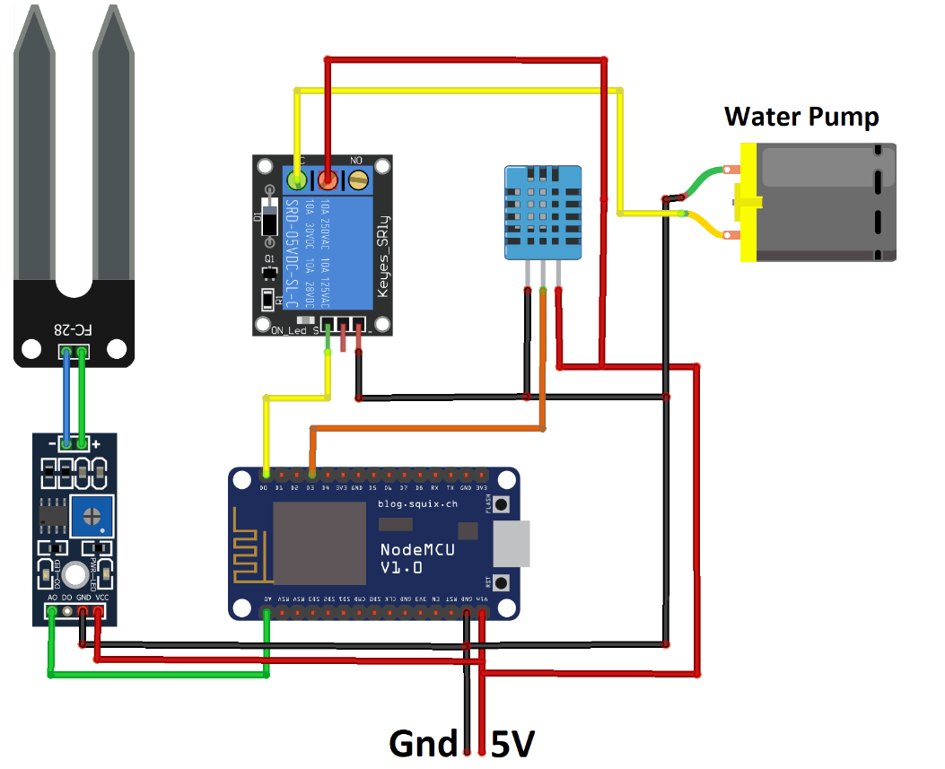

**Implementation Details**

NODE MCU:-

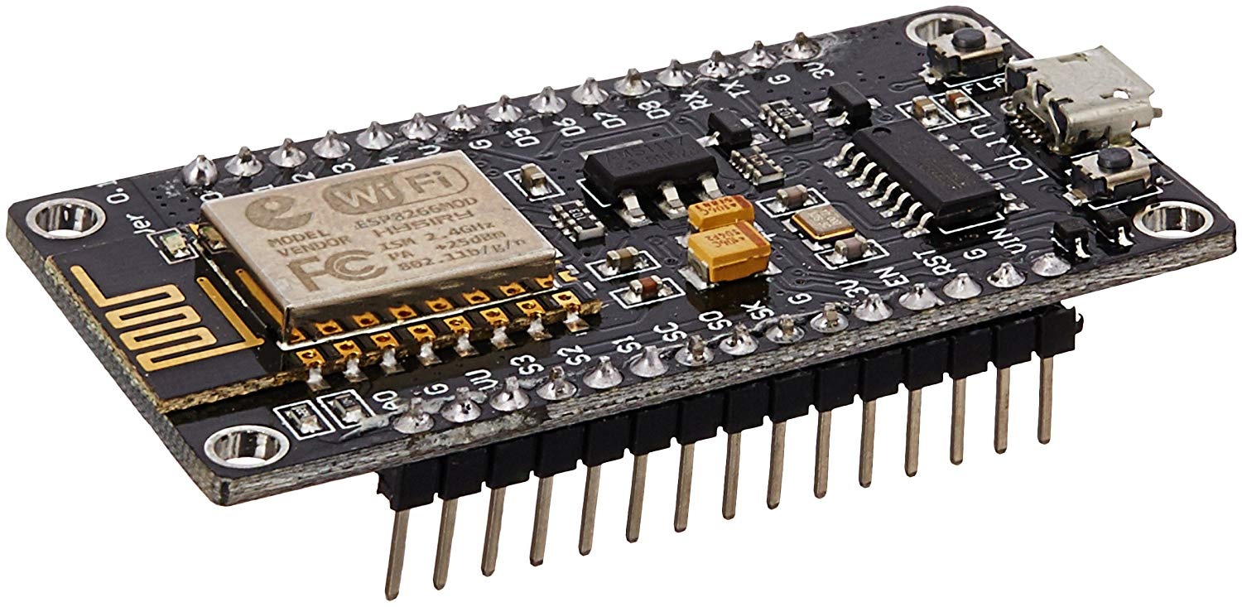

NODE MCU is an open source IoT platform.It includes firmware which runs on the ESP 8266 WIFI SoC and hardware which is based on the ESP 12 module. It is a low cost Wi-Fi module chip that can be configured to connect to the internet for Internet of Things.

ARDUINO is an open source physical computing platform

based on a simple microcontroller board and a development

environment for writing software for the board. It has 14

digital pins, 6 analog pins, 16 MHZ crystal oscillator, a USB

connection, a power source jack and a reset button.

RDUINO is an open source physical computing platform

based on a simple microcontroller board and a development

environment for writing software for the board. It has 14

digital pins, 6 analog pins, 16 MHZ crystal oscillator, a USB

connection, a power source jack and a reset button.

ARDUINO is an open source physical computing platform

based on a simple microcontroller board and a development

environment for writing software for the board. It has 14

digital pins, 6 analog pins, 16 MHZ crystal oscillator, a USB

connection, a power source jack and a reset button.

ARDUINO is an open source physical computing platform

based on a simple microcontroller board and a development

environment for writing software for the board. It has 14

digital pins, 6 analog pins, 16 MHZ crystal oscillator, a USB

connection, a power source jack and a reset button.

ARDUINO is an open source physical computing platform

based on a simple microcontroller board and a development

environment for writing software for the board. It has 14

digital pins, 6 analog pins, 16 MHZ crystal oscillator, a USB

connection, a power source jack and a reset button.

ARDUINO is an open source physical computing platform

based on a simple microcontroller board and a development

environment for writing software for the board. It has 14

digital pins, 6 analog pins, 16 MHZ crystal oscillator, a USB

connection, a power source jack and a reset button.

ARDUINO is an open source physical computing platform

based on a simple microcontroller board and a development

environment for writing software for the board. It has 14

digital pins, 6 analog pins, 16 MHZ crystal oscillator, a USB

connection, a power source jack and a reset button.

ARDUINO is an open source physical computing platform

based on a simple microcontroller board and a development

environment for writing software for the board. It has 14

digital pins, 6 analog pins, 16 MHZ crystal oscillator, a USB

connection, a power source jack and a reset button.

ARDUINO is an open source physical computing platform

based on a simple microcontroller board and a development

environment for writing software for the board. It has 14

digital pins, 6 analog pins, 16 MHZ crystal oscillator, a USB

connection, a power source jack and a reset button.

ARDUINO is an open source physical computing platform

based on a simple microcontroller board and a development

environment for writing software for the board. It has 14

digital pins, 6 analog pins, 16 MHZ crystal oscillator, a USB

connection, a power source jack and a reset button.

ARDUINO is an open source physical computing platform

based on a simple microcontroller board and a development

environment for writing software for the board. It has 14

digital pins, 6 analog pins, 16 MHZ crystal oscillator, a USB

connection, a power source jack and a reset button.

ARDUINO is an open source physical computing platform

based on a simple microcontroller board and a development

environment for writing software for the board. It has 14

digital pins, 6 analog pins, 16 MHZ crystal oscillator, a USB

connection, a power source jack and a reset button.

ARDUINO is an open source physical computing platform

based on a simple microcontroller board and a development

environment for writing software for the board. It has 14

digital pins, 6 analog pins, 16 MHZ crystal oscillator, a USB

connection, a power source jack and a reset button.

ARDUINO is an open source physical computing platform

based on a simple microcontroller board and a development

environment for writing software for the board. It has 14

digital pins, 6 analog pins, 16 MHZ crystal oscillator, a USB

connection, a power source jack and a reset button.

ARDUINO is an open source physical computing platform

based on a simple microcontroller board and a development

environment for writing software for the board. It has 14

digital pins, 6 analog pins, 16 MHZ crystal oscillator, a USB

connection, a power source jack and a reset button.

ARDUINO is an open source physical computing platform

based on a simple microcontroller board and a development

environment for writing software for the board. It has 14

digital pins, 6 analog pins, 16 MHZ crystal oscillator, a USB

connection, a power source jack and a reset button.

ARDUINO is an open source physical computing platform

based on a simple microcontroller board and a development

environment for writing software for the board. It has 14

digital pins, 6 analog pins, 16 MHZ crystal oscillator, a USB

connection, a power source jack and a reset button

ARDUINO is an open source physical computing platform

based on a simple microcontroller board and a development

environment for writing software for the board. It has 14

digital pins, 6 analog pins, 16 MHZ crystal oscillator, a USB

connection, a power source jack and a reset button

ARDUINO is an open source physical computing platform

based on a simple microcontroller board and a development

environment for writing software for the board. It has 14

digital pins, 6 analog pins, 16 MHZ crystal oscillator, a USB

connection, a power source jack and a reset button

ARDUINO is an open source physical computing platform

based on a simple microcontroller board and a development

environment for writing software for the board. It has 14

digital pins, 6 analog pins, 16 MHZ crystal oscillator, a USB

connection, a power source jack and a reset button

ARDUINO is an open source physical computing platform

based on a simple microcontroller board and a development

environment for writing software for the board. It has 14

digital pins, 6 analog pins, 16 MHZ crystal oscillator, a USB

connection, a power source jack and a reset button

ARDUINO is an open source physical computing platform

based on a simple microcontroller board and a development

environment for writing software for the board. It has 14

digital pins, 6 analog pins, 16 MHZ crystal oscillator, a USB

connection, a power source jack and a reset button

ARDUINO is an open source physical computing platform

based on a simple microcontroller board and a development

environment for writing software for the board. It has 14

digital pins, 6 analog pins, 16 MHZ crystal oscillator, a USB

connection, a power source jack and a reset butto

Soil moisture Sensor:-

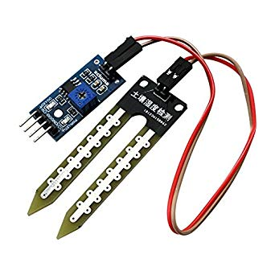

The soil moisture sensor is used to measure the volumetric water content of soil. It is used to monitor soil moisture content to control irrigation. A moisture sensor is used to sense thelevel of moisture content present in

irrigation field. It has a level detection module in which we can set a reference value.

Humidity Sensor:-

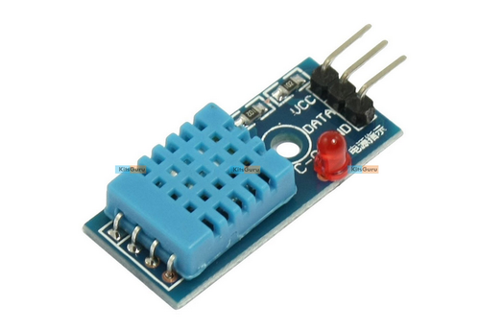

The temperature and humidity sensor is necessary to reduce the watering frequency. That is when the weather gets cooler, less water is needed whereas vice versa in the other case.

**Relay:-**

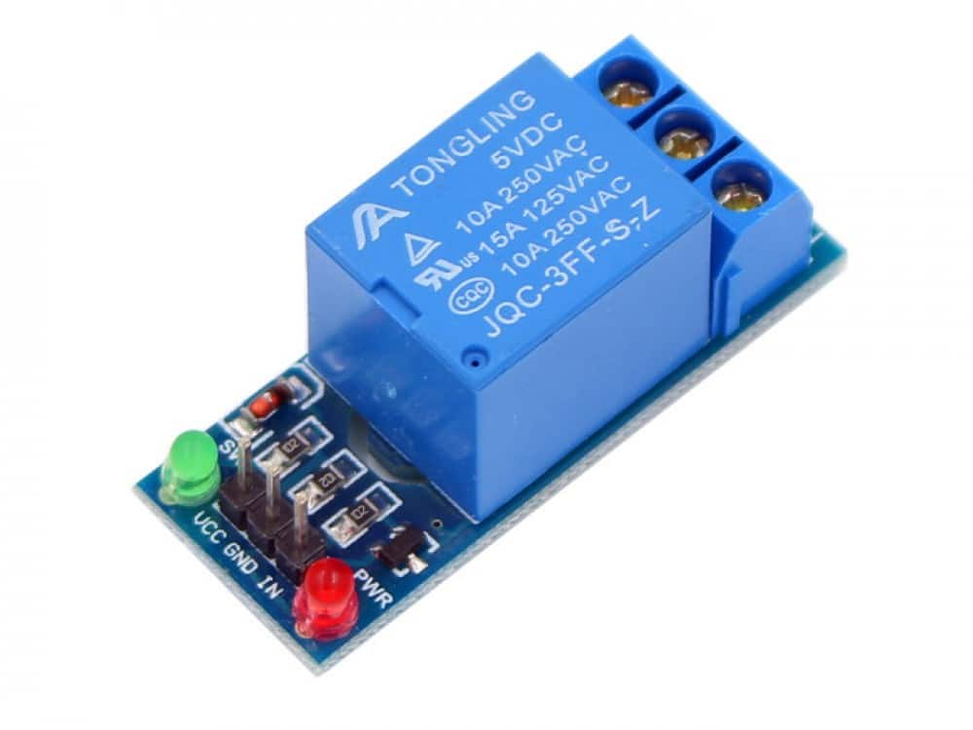

A relay is an electrically operated switch . It consists of a set of input terminals for a single or multiple control signals and a set of operating contact terminals. The switch may have any number of contacts in multiple contact forms.

The implementing steps are:-

* Firstly we will connect the arduino with the soil moisture and humidity sensor .
* we will connect the arduino with the LCD display.
* Then we will connect the arduino with the motor.
* Now the arduino connected with the system through arduino app.
* Then we will run the code through arduino app.
* Read the value shown on display.
* If the moisture level greater than the threshold value then the motor will be OFF otherwise the motor will remain ON

**Contribution**

Basically the members work in a team for the project. We are completing the project effectively. The coding module, report module, hardware module, connecting tools, done by both members.

**Progress:-**

The Project is almost halfway complete.The circuit diagram of the project is completed. The code for the project is in progress. Connections between devices are in progresses. .

**Rreferences:-**

Circuitdigest.com

Electronicsforu.com

Instructables.com